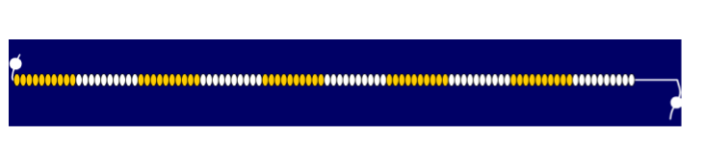

1  + Addition +  add  total  sum  plus  altogether | 2 | 3 | 4 | 5 | 6 | 7 | 8 | 9 | 10  x Multiplication x  lots of  groups of  multiply  multiplied by  product  times
11 | 12 | 13 | 14 | 15 | 16 | 17 | 18 | 19 | 20
21 | 22 | 23 | 24 | 25 | 26 | 27 | 28 | 29 | 30
31 | 32 | 33 | 34 | 35 | 36 | 37 | 38 | 39 | 40
41 | 42 | 43 | 44 | 45 | 46 | 47 | 48 | 49 | 50
51  - Subtraction -  subtract  take away  difference  minus  less than  how many left? | 52 | 53 | 54 | 55 | 56 | 57 | 58 | 59 | 60  ÷ Division ÷  divide  divided by  groups of  how many 3s in?  share  remainder
61 | 62 | 63 | 64 | 65 | 66 | 67 | 68 | 69 | 70
71 | 72 | 73 | 74 | 75 | 76 | 77 | 78 | 79 | 80
81 | 82 | 83 | 84 | 85 | 86 | 87 | 88 | 89 | 90
91 | 92 | 93 | 94 | 95 | 96 | 97 | 98 | 99 | 100
101 | 102 | 103 | 104 | 105 | 106 | 107 | 108 | 109 | 110

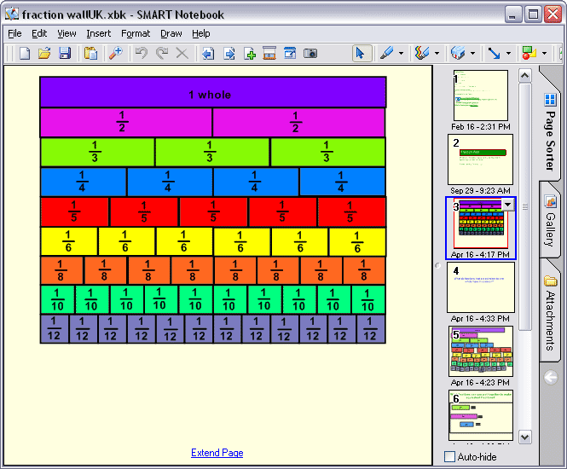
1000 | 2000 | 3000 | 4000 | 5000 | 6000 | 7000 | 8000 | 9000
100 | 200 | 300 | 400 | 500 | 600 | 700 | 800 | 900
10 | 20 | 30 | 40 | 50 | 60 | 70 | 80 | 90
1 | 2 | 3 | 4 | 5 | 6 | 7 | 8 | 9
X | 1 | 2 | 3 | 4 | 5 | 6 | 7 | 8 | 9 | 10
1 | 1 | 2 | 3 | 4 | 5 | 6 | 7 | 8 | 9 | 10
2 | 2 | 4 | 6 | 8 | 10 | 12 | 14 | 16 | 18 | 20
3 | 3 | 6 | 9 | 12 | 15 | 18 | 21 | 24 | 27 | 30
4 | 4 | 8 | 12 | 16 | 20 | 24 | 28 | 32 | 36 | 40
5 | 5 | 10 | 15 | 20 | 25 | 30 | 35 | 40 | 45 | 50
6 | 6 | 12 | 18 | 24 | 30 | 36 | 42 | 48 | 54 | 60
7 | 7 | 14 | 21 | 28 | 35 | 42 | 49 | 56 | 63 | 70
8 | 8 | 16 | 24 | 32 | 40 | 48 | 56 | 64 | 72 | 80
9 | 9 | 18 | 27 | 36 | 45 | 54 | 63 | 72 | 81 | 90
10 | 10 | 20 | 30 | 40 | 50 | 60 | 70 | 80 | 90 | 100

1 metre = 100 centimetres 1 m = 100cm
1 kilometre = 1000 metres 1 km = 1000m
1 centimetre = 10 millimetres 1 cm = 10mm

1 kilogram = 1000 grams 1 kg = 1000g
½ kilogram = 500 grams ½ kg = 500g

1 litre = 1000 millilitres 1 l = 1000ml
½ litre = 500 millilitres ½ l = 500ml

+

1 year = 365 days or 52 weeks or 12 months
1 week = 7 days
1 day = 24 hours
1 hour = 60 minutes
1 minute = 60 seconds

